A Spotlight on the Caring and Dedicated Staff of our Community Schools

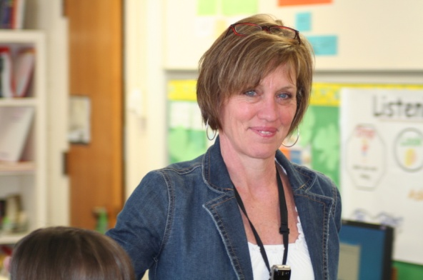Bonnie Meldrim is a second grade teacher at Randall Elementary School. Bonnie exemplifies all the qualities of excellence that any parent would desire in their child’s teacher.

Bonnie has boundless energy to keep up with her class of 24 second graders. She works with these children individually, in small groups and in large groups to ensure that they all develop the reading skills that they need to be successful students. Mrs. Meldrim has skill and expertise in managing her students and teaching reading that very much warrants her recognition as Cortland’s 2009-2010 “Teacher of the Year.”

In addition to her skillful teaching, Bonnie works to provide so much more for her students. Every day Bonnie provides students with guidance in learning how to be good, caring, well rounded individuals. She helps all of her students through any minor crises that they might have, provides them with supplies that they might be without, and still finds time to assist with the PTO activities.

Bonnie is also always eager to share her experiences with other teachers and soon-to-be-teachers, opening up her classroom for visitations by her colleagues and SUNY Cortland teacher candidates.

Our hats are off to Bonnie Meldrim – a very caring and dedicated teacher!