Getting to know Mrs. Yunghans

* Was born and raised on Long Island [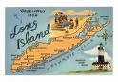](http://images.google.com/imgres?imgurl=http://libn.com/thedebateroom/files/2009/05/li-00063-cgreetings-from-long-island-new-york-map-posters.jpg&imgrefurl=http://libn.com/thedebateroom/2009/05/20/cantor-li%E2%80%99s-delegation-didn%E2%80%99t-serve-us/&usg=__RnDABrAfrDuDPieB_EkCIwkxw30=&h=278&w=400&sz=41&hl=en&start=9&um=1&tbnid=aRsn60AvFNkbBM:&tbnh=86&tbnw=124&prev=/images?q=long+island+map&hl=en&um=1)
* Has one older brother named Seth [](http://www.roie.org/images/ph007.jpg)
* Went to SUNY Fredonia [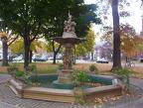](http://images.google.com/imgres?imgurl=http://pics4.city-data.com/cpicc/cfiles39372.jpg&imgrefurl=http://www.city-data.com/picfilesc/picc39372.php&usg=__4aVW_ZSZHAWQa2Uhxxl9Q9kPxhM=&h=616&w=816&sz=171&hl=en&start=3&um=1&tbnid=kWynrBvQFwY7FM:&tbnh=109&tbnw=144&prev=/images?q=fredonia+ny&hl=en&um=1)
* Has taught special education for 10 years
* Is married and has two wonderful children[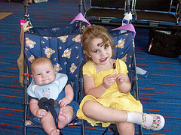](http://www.flickr.com/photos/leigray/3799082429/)
* Favorite music Dave Matthews Band[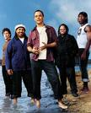](http://www.dreamtix.com/images/davematt.jpg)
* Favorite food is Chinese
* Favorite Color is Green
* Favorite hobby is making crafts
* Favorite movie is Return to Me [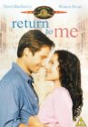](http://www.imdb.com/rg/action-box-title/primary-photo/media/rm3143932928/tt0122459)
* Favorite Author is Mitch Albom[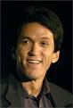](http://images.google.com/imgres?imgurl=http://images.usatoday.com/life/_photos/2006/09/25/albom.jpg&imgrefurl=http://www.usatoday.com/life/books/news/2006-09-24-albom-book-starbucks_x.htm&usg=__0MGzsWusTyPzIrWJ2nKD00bpg60=&h=362&w=245&sz=20&hl=en&start=13&um=1&tbnid=b1EiJpqjC2HdtM:&tbnh=121&tbnw=82&prev=/images?q=mitch+albom+books&hl=en&sa=N&um=1)