REGENTS EARTH SCIENCE EXPECTATIONS

What you can expect from me:
-S upportive
-C lear presentation of classroom goals
-I nvolved in your learning process
-E nergetic and maybe a little entertaining
-N ever say it can’t be done
-C oncerned for your well being
-E xpectations are high

-Available for extra help at _2nd Period__________ _3rd Period__________

_12 Period__(even)____ ___________________

What I expect from you:
-Be on time
-Be prepared for class
-Be respectful to all members of the class
-Listen and Question
-Make up all work if class is missed

Material useful for class:
3 ring notebook with folders
Colored pencils, and markers
Calculator
An Open Mind

Classroom Website is located at www.cortlandschools.org
go to //schools (Jr/Sr/ High School) // Science // Earth Science

Assignments, Labs, and helpful web pages are all there.

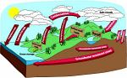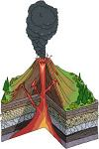

Grading System:
Unit tests, Quiz grades, Homework, and Participation = 75%

Laboratory Work and Write ups = 25%
Lab Policy:
The student will be qualified to take the Regents’ exam at the end of the year if 90% of the lab reports for the 40 weeks of class are completed in a satisfactory manner and submitted on or before the lab report deadline.

Regents Earth Science Requirements

The student will receive regents credit for Earth Science when:

- Student becomes certified by completing the regents laboratory requirement in a satisfactory manner.
- Student scores at least 65% on the regents exam and has a passing final average in class.

These guidelines will be discussed during class. If you have any questions or criticisms, please fell free to contact me at 758-4110 ext. 1280 or e-mail at julrich@cortlandschools.org

Have a good year

Classroom Expectations for Earth Science

Student’s Name _____________________________________________

Parent or Guardian’s Name ______________________________________

Telephone and e-mail____________________________________________

Date ________________

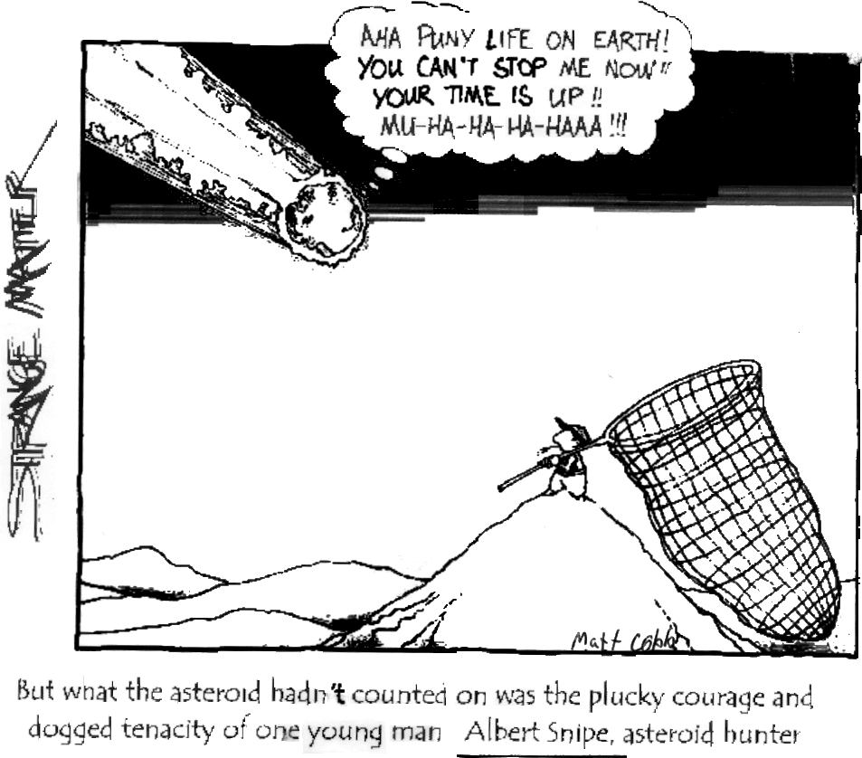




Grading System:
Unit tests, Quiz grades, Homework, and Participation = 75%

Laboratory Work and Write ups = 25%
Lab Policy:
The student will be qualified to take the Regents’ exam at the end of the year if 90% of the lab reports for the 40 weeks of class are completed in a satisfactory manner and submitted on or before the lab report deadline.

Regents Earth Science Requirements

The student will receive regents credit for Earth Science when:

- Student becomes certified by completing the regents laboratory requirement in a satisfactory manner.
- Student scores at least 65% on the regents exam and has a passing final average in class.

These guidelines will be discussed during class. If you have any questions or criticisms, please fell free to contact me at 758-4110 ext. 1280 or e-mail at julrich@cortlandschools.org

Have a good year

Classroom Expectations for Earth Science

Student’s Name _____________________________________________

Parent or Guardian’s Name ______________________________________

Telephone and e-mail____________________________________________

Date ________________

