My Earth “Selfie”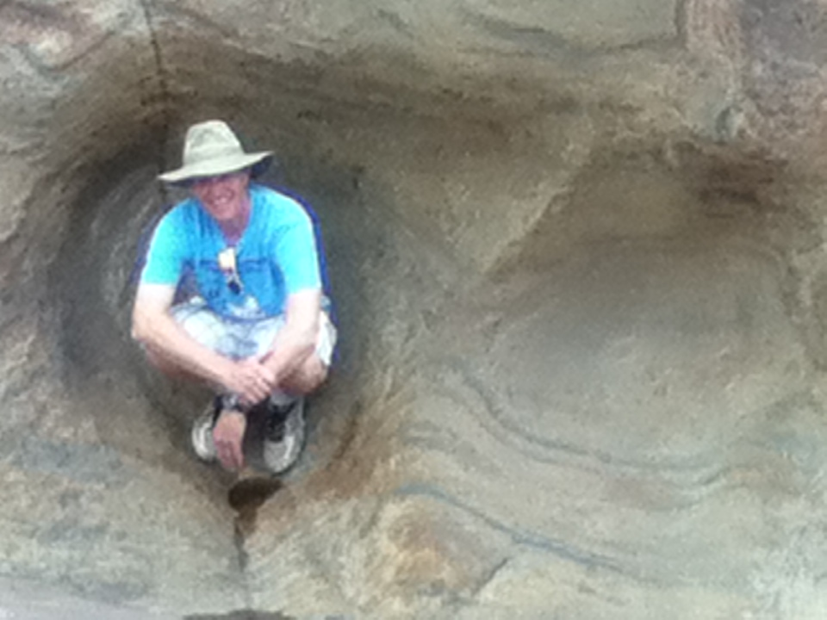

The following list consists of phenomena that happen in and on this awesome planet of ours. Your job for this long term project is to document these phenomena with a digital camera and include yourself in the picture hence the My Earth “Selfie”. This entire list will be discussed throughout the year. Many thanks go to Mr. Greg Flick (teacher in Cicero-North Syracuse) for much of this has been shared with me from his class.
-You need to choose at least 10 of them.
- I would like this project completed by the day after Memorial Day Tuesday May 31,
2016. This is the last day to turn anything in. It can be turned in anytime before that
date as well.

This is a great project to get your family and friends involved in too! Essentially you are creating fieldtrips for yourself. Have fun and be careful pay attention to your surroundings when taking the pictures.
This will be a 4th quarter grade and will count as 2 test grades.

Submission of this project will be in powerpoint with a picture/selfie and then answers to the questions posed named with your name, in the folder earth science in your class period in the shared drive.

1. States of Matter: Take a series of pictures showing how a substance can exist in all 3 states of matter (solid, liquid, gas). Describe each process that must occur in order for the substance to change from one state to another. Water naturally exists on earth in all 3 states of matter. How much energy is required for 1g of water to melt? How much energy is required for 1g of water to vaporize?
2. Four Seasons: Take a series of four photos, in exactly the same spot showing how the location looks over three seasons (summer, fall, winter, and spring). Look to show differences in each photograph to depict how the climate has changed (large leaves = summer, colorful leaves = fall, no leaves = winter, small green leaves = spring). For your captions note the date and time each picture was taken, as well as the temperature.
3. Sun's Shadow: Pound a stick into the ground, and on a sunny day on or about the same day each month take a picture of the stick and its shadow. Take the picture as close to solar noon as you can. As part of your captions measure the length of the shadow each time. The length will shorten as we move towards the winter solstice and shorten once again as we move towards the summer solstice. Explain what a solstice and an equinox is, and why the shadow changes length. Get started on this soon - I want to see at least six photos in the series.
4. Constellation –A selfie will be hard for this so locate a constellation center it in your picture, label the direction you are facing and the month, day, and time of the picture. You will not be able to be in this picture as all the other ones. Name the constellation and tell me the story behind its name.
5. Sequence of sunrises or sunsets over a couple weeks period. Pictures must be taken at the same spot. Explain the direction of the movement of the sun and what season you are in.

6. Phase of the Moon: Take a picture of the moon anywhere between waxing and waning crescents. It may be easier to take a picture of a moon when we can see it during the day. What causes the different phases of the moon? What other effects does the moon have on our planet?
7. Rainbow: Try to get a nice bright one so all the colors are visible! What causes rainbows to form? Why do we see color at all?

8. Radiation – take a series of photographs to show how ultraviolet light alters the appearance of certain materials. Discuss the dangers of UV rays to your skin & what acts to protect us from these rays in the atmosphere
9. Frost Action: This is not frost on a windshield!! This is a type of physical weathering. Any type of frost action will do. Explain how your picture depicts frost action. Why does frost action happen? Can the damage be repaired?
10. Condensation: Any type will do. What do you know about the air temperature and the dew point temperature for condensation to occur? What time of day is condensation usually present? And don't take a picture of condensation on a can of soda (or anything else like that!)
11. Cloud Types: Take a picture for each type of cloud: cumulous, stratus, cirrus. Describe how clouds are created & the distinguishing characteristics of each cloud type. What clouds are associated with rainstorms?
12. Fog: Take a picture that clearly shows fog in an area. How is fog created? When is fog most likely to be seen?

13. Wind: Show the effect of the air moving. Discuss what causes wind, how it is named, and how pressure gradient affects it. If you are standing with your back to the wind, how can you tell where the low pressure center is located?
14. Cloud Base: Take a picture of a group of clouds that clearly shows the flat bottoms. Describe the process of cloud formation & explain why the bottom is flat – why can’t the clouds look ‘puffy’ on the bottom?
15.Snowfall rate – You will have to set up for this one so listen to the weather forecast. Take a before selfie of a measuring stick and then an after selfie of the measurement of the snow amount from one storm. Determine the rate of snowfall in inches/hr. (show your work)
16. Lake Effect!: Take a photo of yourself in a lake effect snowstorm. These snow storms are unique to areas adjacent to the Great Lakes. . Not all snow is lake effect snow, so check the doppler radar to make sure it's a lake effect storm. Describe how and why lake effect occurs, why the snowflakes are different from other types of snow showers.
17. Oxidation: DO NOT TAKE A PICTURE OF METAL RUSTING. Show me an example of oxidation in the natural environment. Please be careful not to confuse lichens with rust. How do soils show that oxidation has occurred? What type of weathering is this?
18. Abrasion: Find abrasion that’s occurred naturally (not stones from your landscaping!) Discuss how they were created and the forces that acted on them. How long have these rocks taken to form their characteristic shape?
19. Breaking Wave: Not the swash or backwash, but the actual breaking wave . Show which way the swash and backwash are going. If you can find something on the beach that floats, throw it in and see if you can determine which compass direction the long shore current is going.
20. Stream Development: Use caution near the water! Any local stream will do. DO NOT USE A DRAINAGE DITCH - THAT IS MAN-MADE. Identify what stage the stream is in. See if you can find a large meander to show the difference between erosion and deposition. Indentify in your picture where erosion would be dominant and where deposition would be dominant. Look for small pebbles, or grains of sand being carried along by the stream. What physiographic feature has your stream created?

21. V-Shaped Valley: Complete this photo also at a stream location. Look for an area where there are steep cliffs on both sides of the stream that appear to form a “V” when looking up from below. What stage of development is shown? Why is the top wider than the bottom? Is this an example of weathering, erosion, or deposition? How can you tell?
22. Waterfall: Go to a waterfall and take a picture of it. There are several parks in Onondaga County and Madison County that have waterfalls. Show the water falling, estimate or determine the height of the waterfall, and describe the valley cut by the stream, what kind of rock the water is falling over, and if it is an example of weathering, erosion, or deposition. What stage of stream development is shown?
23. Glacial Rocks (Erratics): I want a picture of a big one, at least as big as a person: What is a glacier? How do we know that the ice age ‘just’ ended? What special features are found on glacially transported cobbles and boulders? You can find rocks that farmers collected next to a field that they removed when plowing, or look for specific rocks at the stream, or even near your house as landscaping. Remember, our underlying bedrock is sedimentary rock; this means that rocks deposited by a glacier will be different. Make sure your photograph of glacial erratics is accurate. What other features could we find locally to indicate a glacier once covered this area? How are glaciers beneficial to our local economy?
24. Soil Profile: Find someplace where someone has dug a deep hole, maybe a ditch that has recently been dug out, or dig your own. You can scrape away the sides of the cliff near the top when you are taking your V-shaped valley picture. Label the different layers of your soil profile that are visible. Why is soil considered a non-renewable resource? How has our soil contributed to the development of our community?

25. Agents of Erosion: There are 5 causes of weathering & erosion on earth (water, wind, waves gravity, glaciers). Take at least 3 pictures showing rocks or sediments affected by 3 different agents. What features are shown in your pictures that indicate the agent that acted on them?
26. Flooding: Show a flooded landscape (from a distance so you are not putting yourself at risk!) Explain what the water table is & the factors that led to the flooding. What season are we most at risk from flooding?
27. Cave or Cavern: Visit a cave such as Howe Caverns, or another similar location. What type of rock is the cavern made of? Describe how it was created. Inside, you should see stalactites & stalagmites (Get a selfie with them) – what’s the difference? How are these formed?
28. Soil Creep: Take a picture showing the effect of soil creep on a landscape. Describe how & why soil creep occurs. Explain why trees and man-made posts/poles are affected.
29. Wave motion in a body of water – Your selfie must show some form of wave motion. Use the picture to try to determine the wavelength of the wave (include your finger for scale)
30. Abrasion: Find abrasion that’s occurred naturally (not stones from your landscaping!) Discuss how they were created and the forces that acted on them. How long have these rocks taken to form their characteristic shape?
31. Rock Outcrop: This photo should show several layers of rock, or, if metamorphic or igneous rock some interesting structure. In addition, you must identify the rock type(s) and specific rocks in the outcrop. If the outcrop has a fault in it, identify it in the photo.
32. The floor of the Cortland Post Office?: What type of rock is this?
33. The Cobblestone Church: Why is it called this? Try to get a picture of each type of rock
34. Oldest NYS Rocks - photograph the oldest rocks in NYS! Identify where they are, how they were created & how the oldest rocks in the state remain at such a high elevation.
35. Fossil evidence – Take a selfie with you either holding the fossil or standing/sitting next to the rock it is in. What type of rock is this fossil found in and try to name it with the help of your ESRT. Was this fossil from a terrestrial or marine environment?
36. Natural Resource: We have many natural resources that we use that can be found locally. Find a natural resource, and explain what it is. Is it renewable or nonrenewable? How is it valuable to us? DO NOT use natural resources that can be grown, like trees. This is Earth Science, not Biology! Mining operations, a dam holding water, a drilling rig drilling for oil or gas, etc.
37. YOU TELL ME!: Maybe you have an idea for a picture/scenario I haven’t listed. Ask me ahead of time, or maybe just take the picture and check with me afterwards. In any case, great ideas can lead you to great photographs.

REMEMBER!!
This project takes planning - Get Started Early!
You have approximately Eight MONTHS to complete this project, but winter makes it harder to get around and see obtain some of the photos, and some of your options require multiple photos to be taken over a series of months, so get started as soon as possible. I will be asking for updates periodically throughout the year.
Your final submission is DUE MAY 31, 2016.
*You may NOT use a picture more than once – you need to obtain DIFFERENT pictures for each item on the list – you may use the same location for multiple items, but not the exact same spot and/or picture.
*** SAFETY DISCLAIMER***
You are to be extremely careful when out taking pictures – I do NOT want to see you hurt in order to get a photo for this project! Furthermore, you are not allowed to trespass in order to get a photo! I am not responsible for any of your actions or injuries in the field!

