Climate Inventory

- Can you describe what Climate is with: Temperature and Humidity

Also include

Humid, Arid, Polar, Temperate, Tropical

- How do the following Geographic topics affect Climate?

Latitude

Elevation

Mountain Barriers

Large Bodies of Water

Prevailing Winds

Ocean Currents

Urban Areas
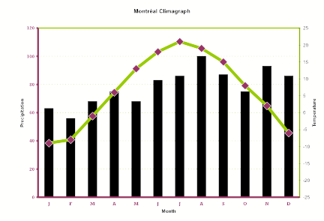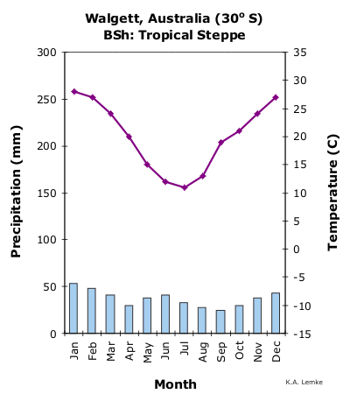

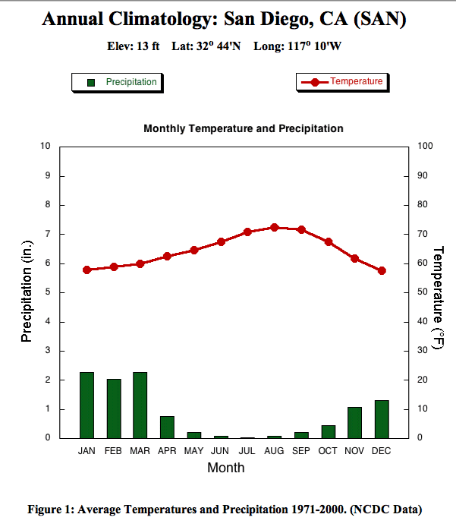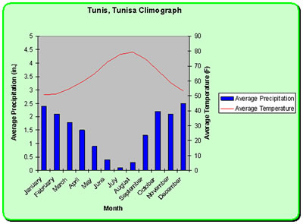

- Interpret the above charts. How are they similar and different?

- How do water budgets enter into the discussion on Climate?

- Be able to tell a story of a raindrop using proper water cycle vocabulary.

- Know how sediment sizes affect Porosity, Permeability, and Capillarity. Also what other factors affect them.

