Energy Inventory

- Using the E.M. Spectrum in your ESRT know the relationships in :
Speed/Wavelength/Frequency/Energy

- Label all parts of a Wave.

- What gives off electromagnetic radiation?

- What can happen to E.M. radiation?

R R A S

- What are the three types of Energy Transfer?

C C R

- A good Absorber is a good ______________________

- Describe the natural direction of Heat Flow?

- Determine the Heat Source and Heat Sink of various energy systems.

- What is the definition of Temperature?

- Describe the Phase Changes with a time –temperature graph. Especially know the temperatures for water phases. What is Latent Heat and where does it apply to the graph?

- Convert temperatures using all 3 temperature scales in the ESRT.

- How does the Specific Heat data apply to this unit of energy?

- Define Insolation and show the relationship of intensity and duration of insolation that it has upon the earth through the year.

- Fill in the following graph to tell the relationship between intensity and angle of insolation.

Oº 90º

- Explain why the Earth’s shape affects the intensity of insolation.

- Describe the Greenhouse effect. How does wavelength play a part in this? What gases play a part in this?

- Explain why the maximum and minimum temperature readings are at different times of the year and the day than the maximum and minimum intensities of insolation recordings at various locations.

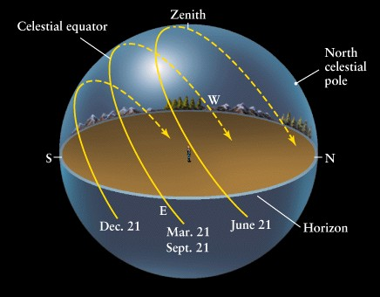
Understand this diagram

