Topographic Maps Inventory

- What do topographic maps use to show elevation?

- Features that can be found on a topo map:
  - Lat/Long
  - Elevation
  - Roads, buildings, trails, boundaries
  - Bodies of water
  - Gradient
  - Distance

Practice with this map
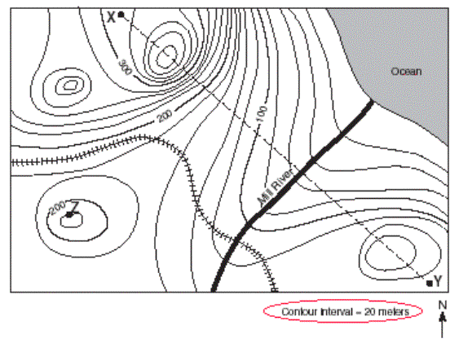
- What direction is the Mill River flowing?

- Determine the elevations of X ____________ Y _______________ Z _____________

- What is the highest possible elevation on the map?

- What does the profile look like from X to Y?

- How would you determine distance on a map?

- If one centimeter is 1 kilometer determine several distances.

- Where is it steeper or flatter? How do you know?

- Add two roads on the map from point Z to the ocean, one being shorter but steeper and the other longer but more gradual.

- Now determine some gradients between 2 places.

