**Earth Dimensions Inventory**

1. Use proper terminology when dealing with latitude and longitude such as:

Meridian/Parallel/Hemisphere/Polar/Equatorial/Minutes of a degree

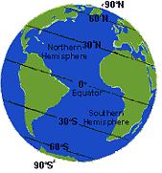 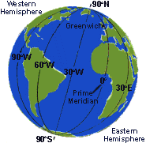

1. Determine locations on the Earth when given lat./long. Coordinates and determine coordinates when given a specific location.
2. Know the relationship of Polaris and Latitude.
3. Determine the proper direction(N,E,S,W) of movement from or to a specific point.
4. Define Greenwich time and know the relationship of Time and Longitude.
5. How many time zones are there? Why are there time zones?
6. The shape of the Earth is?
7. The best model for the Earth is?
8. List characteristics for the following spheres.

Lithosphere Hydrosphere Atmosphere.

1. Determine **pressures**, **temperatures**, and **thickness** of the layers in the Earth’s interior.



1. Determine **thickness, elevation, temperature, pressure, density of water** for the Earth’s atmosphere. Be able to distinguish the **different layers** of the atmosphere.

