Landscapes Inventory

- List the different characteristics of the three types of Landscapes.

________________________ ______________________ _____________________

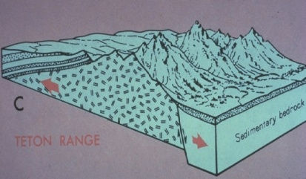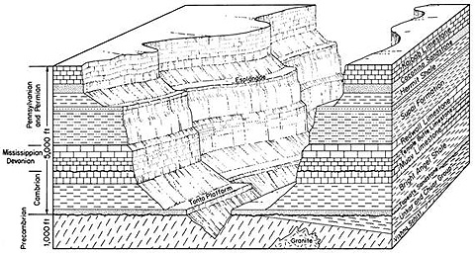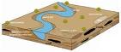

- Explain what you would look for to find the boundaries between different landscapes.
(pages 2 and 3 in your ESRT)

- Use the following topics when discussing Landscape development: (use the back)

- Climate
- Rock type
- Erosional Agent
- Plate Motion
- Time
- Human Activity

If you think about it every unit we have discussed this year will have some type of affect on the Landscapes.

