Geologic Time Inventory

- Understand the following concepts and relationships when discussing Time:
- Relative Age
- Absolute Age
- Uniformitarianism
- Superposition
- Original Horizontality
- Inclusions
- Cross-cutting
- Contact Metamorphism
- Unconformities

- Interpret Bedrock profiles using the above ideas and determine oldest to youngest.
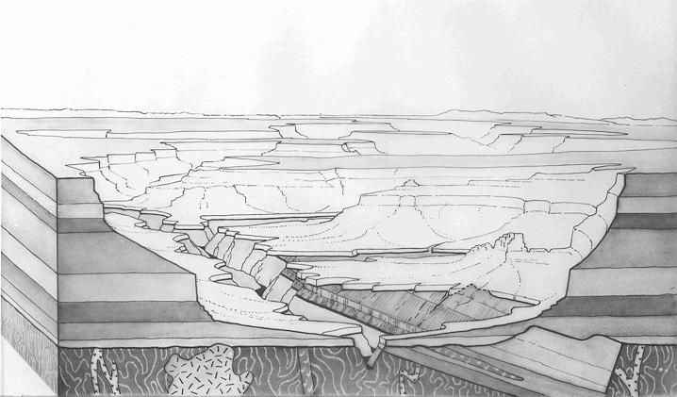

- Define radioactive isotope.

- Be able to determine age of something when given % of parent and daughter isotopes using the half-life information found in the ESRT.

100%--______-______-______-_______-_______-_______
- Interpret the half life curve.

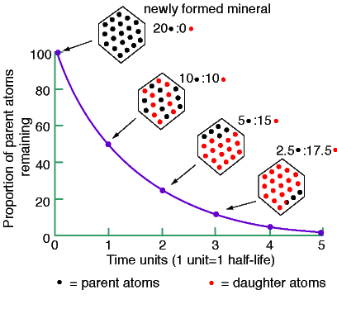
- What radioactive isotope would be more useful for human remains? Why

- Define Fossil and give the many types.

- Using pages 8 and 9 of the ESRT to;
a) determine when different episodes of Earth history began and ended.
b) know what caused all the boundaries between time ages?
c) know what index fossils are used for various time periods.
d) realize what time periods New York actually has rocks to read.
e) follow the lifeline of various forms of life when they existed.
f) apply all your plate tectonics knowledge with the time table.

- Define Extinction.

- Define Correlation (walking the outcrop).

