Cortland Enlarged City School District End of Year APPR Evaluation with SLO Summary
2021-2022
Teacher: ________________________________________ Building: ____________________________________
- Observation Rating _______Rubric Score __H __E __D __ I Rating
 |  | Overall Rating from Rubrics
 | Minimum |  | Maximum
(highly effective) H | 3.5 |  | 4.00
(effective) E | 2.5 |  | 3.49
(developing) D | 1.5 |  | 2.49
(ineffective) I | 0.0 |  | 1.49
- Student Learning Objective Rating _______ __H __E __D __ I Rating
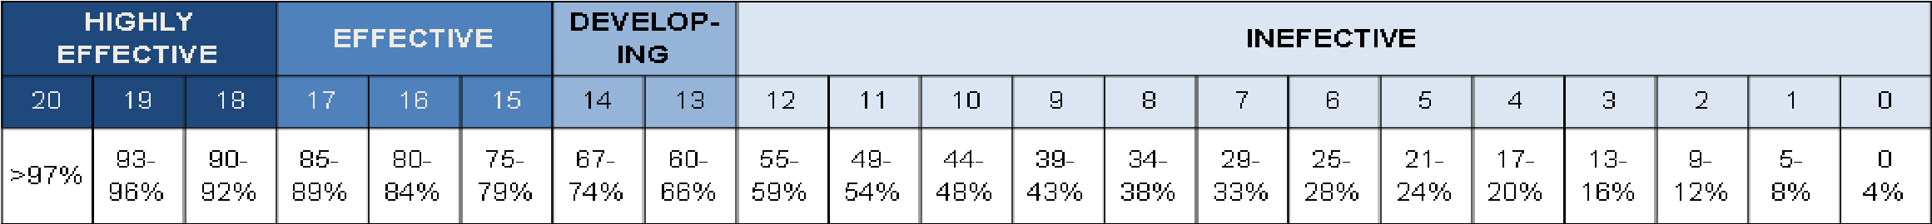
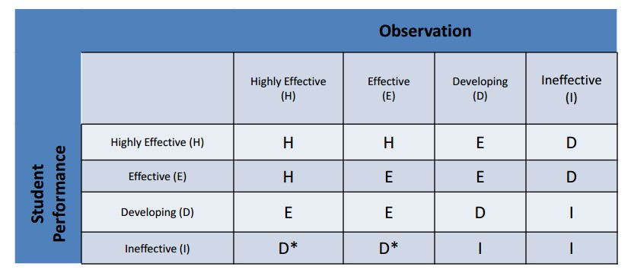Final Rating: ____________

Advisory Score (Applies to 4-8 ELA and Math Only) |  | Transition Score
State Provided Growth Score |  |  | Student Learning Objective HEDI
HEDI Observation |  |  | HEDI Observation
Overall HEDI Rating |  |  | Overall HEDI Rating
Evaluator Comments from End-Of-Year Meeting:
Teacher Comments from End-Of-Year Meeting:

Staff Signature Administrative Signature Date

