Name ________________________________________________________ Period__
Leadership Seminar

7 Habits of Highly Effective Teens
The Set Up

Important principles in my life | Why the principle is important to me

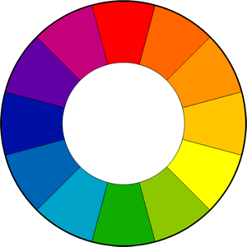
In the center circle, list the principles that guide your life. On the spokes, list the things in your life that the principles influence.

