- es-ES

The Skin Cancer Foundation recommends that everyone practice
monthly head-to-toe self examination of their skin, so that they can find
any new or changing lesions that might be cancerous or precancerous.
Skin cancers found and removed early are almost always curable. Learn
about the warnings signs of skin cancer and what to look for during a self
examination. If you spot anything suspicious, see a doctor.
What you'll need: a bright light, a full-length mirror, a hand mirror, 2 chairs or stools, a blow dryer, body maps and a pencil.
1 | 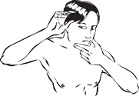  Examine your face, especially the nose, lips, mouth, and ears - front and back. Use one or both mirrors to get a clear view.
2 | Thoroughly inspect your scalp, using a blow dryer and mirror to expose each section to view. Get a friend or family member to help, if you can.
3 | Check your hands carefully: palms and backs, between the fingers and under the fingernails. Continue up the wrists to examine both front and back of your forearms. | 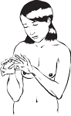
4 | Standing in front of the full-length mirror, begin at the elbows and scan all sides of your upper arms. Don't forget the underarms | 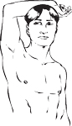
5 | Next focus on the neck, chest, and torso. Women should lift breasts to view the underside. | 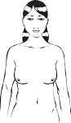
6 | With your back to the full-length mirror, use the hand mirror to inspect the back of your neck, shoulders, upper back, and any part of the back of your upper arms you could not view in step 4. | 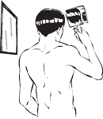
7 | Still using both mirrors, scan your lower back, buttocks, and backs of both legs. | 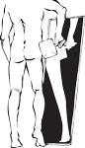
8 | Sit down; prop each leg in turn on the other stool or chair. Use the hand mirror to examine the genitals. Check front and sides of both legs, thigh to shin, ankles, tops of feet, between toes and under toenails. Examine soles of feet and heels. | 