Station 1
Nutrition Labels
Station 2
Reading Labels for Sugar Content
Station 3
Reading Labels for Sodium Content
Station 4
Good vs bad fats
Station 5
Nutrition of Energy Drinks
Station 6
Fast Food Menu
Station 7
Energy Needs
Station 8
Portion Sizes
Station 9
Antioxidants
Station 10
Healthy, Hunger Free Kids Act
Station 11
Eat This, Not That
Station 12
Choose My Plate Nutrients
Station 13
Choose My Plate Supertracker Reports

Station 1: Nutrition Labels
Use the food label to answer the following questions:
1. What is the serving size?
2. How many servings are per container?
3. How many calories are in one serving?
4. How many calories are in two servings?
5. How many calories from fat are in one serving?
6. How many grams of carbohydrates are in two
servings?
7. Using the information on the Nutrition Label
worksheet, which nutrients from the wrapper
label are considered a good (high source)?
8. Using the information on the Nutrition Label
worksheet, which nutrients from the wrapper
label are considered a bad (low) source?

Station 2: Reading Labels for Sugar Content

1. Using the food labels, how many different
types of sugar appear on the labels?
2. Which cereal has the lowest sugar content?
How do you know?
3. How many sugar cubes are in the cereal with
the highest sugar content? How do you know?
4. How many grams of sugar is an estimated daily
limit?

Station 3: Reading Labels for Sodium Content

1. Using the food labels, how many different
types of sodium appear on the labels?
2. Which food has the lowest sodium content?
How do you know?
3. How many mg of sodium are in the food with
the highest sodium content? What is the %
daily value of that much sodium?
4. How many mg of sodium is an estimated daily
limit?

Station 4: Good Fats vs. Bad Fats

1. What is the difference between saturated and
unsaturated fats? Which foods provided are
saturated fats? Unsaturated fats?
2. What kinds of fats should be limited in your
diet? Why?
3. What is the difference between polyunsaturated
fats (PUFAs) and monounsaturated fats (MUFAs)?
4. Why are trans fats unhealthy?
5. Which product is the healthiest in terms of fat
content? Why?

Station 5: Nutrition of Energy Drinks
1. How many servings are in the Red Bull?
2. How many servings are in the RockStar?
3. How many servings are in the AMP?
4. How many servings are in the Monster?
5. How many sugar cubes are in each of the
drinks?
6. Which drink has the least amount of caffeine in
it per serving?
7. Which drink has the least amount of sugar in it
per serving?

Station 6: Fast Food Menu
Search the internet for your favorite fast food nutrition menu.
1. You have $10.00 to spend for lunch. What
would you choose?

2. Does your meal meet the Choose My Plate
guidelines? What is it missing?

3. What could you choose from the menu that
would better meet the guidelines?

4. If you had your original meal selections for
lunch, what could you choose for the rest of
the day to meet your personalized Choose My
Plate guidelines?

Station 7: Energy Needs

Compute your basal metabolism calories, your physical activities calories and your food digestion calories using the formulas listed.

1. Basal metabolism calories for the day =

2. Physical activities calories for the day=

3. Food digestion calories for the day=

4. Total energy needs for the day=

Station 8: Portion Sizes
Match the following foods with the appropriate object serving size.

1. 1 cup of spaghetti

2. an ounce of cheese

3. a bagel

4. 3 ounces of meat

5. a tablespoon of peanut butter

6. a baked potato

7. a pancake

8. How do these portion sizes compare to your
own?

Station 9: Antioxidants

After reading the article on antioxidants, answer the following questions.

1. What are antioxidants?

2. Why are they important for our diet?

3. What are some types of antioxidants? In what
foods are they found?

Station 10: Healthy, Hunger Free Kids Act

1. Summarize the purpose of the Healthy, Hunger
Free Kids Act.

2. Summarize the updated standards for school
meals.

3. How have our school lunches changed to meet
these standards?

4. Do you agree with these new standards? Why
or why not?

Station 11: Eat This, Not That

Spend some time looking at the Eat This, Not That books.

1. What are three foods that seemed healthy but
were found to be unhealthy? What were the
hidden health concerns?

2. What are three things you learned from these
resources?

3. Would you use these types of resources in your
own life? Why or why not?

Station 12: Choose My Plate Nutrients
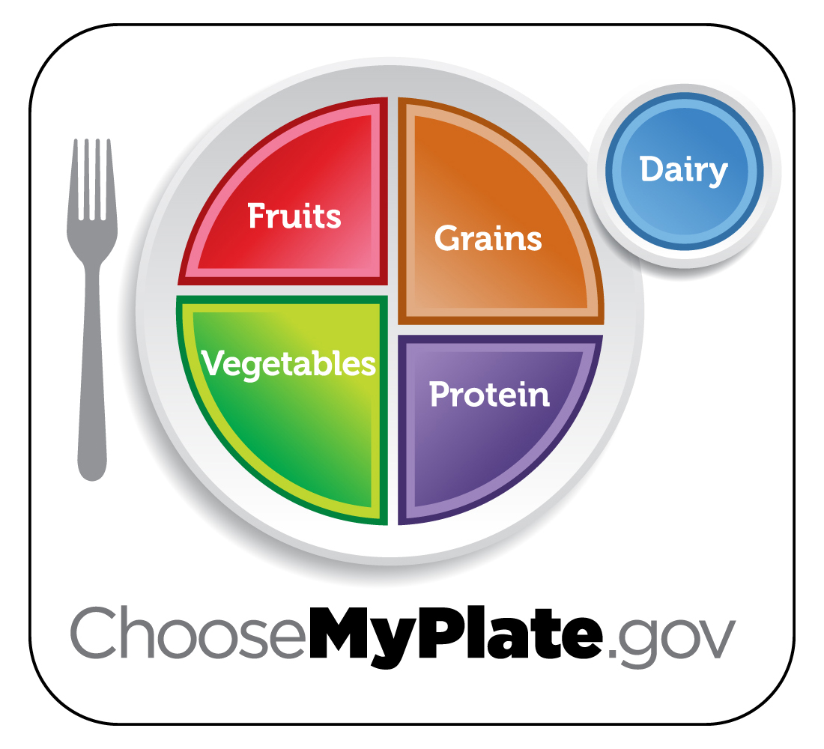
1. Which of the seven essential nutrients
(carbohydrates, water, protein, fat, vitamins,
minerals, fiber) are provided by each food
group listed on Choose My Plate?

2. For each sections of the plate, list three healthy
food options.
Station 13: Supertracker Reports
Using the Supertracker on www.choosemyplate.gov, make sure you have typed in all of your foods and activities for seven days. Also make sure that you’ve entered the appropriate foods and activities on the right calendar date.
Click on “My Reports” and print out the following reports:
Food Groups & Calories
Nutrients
Food Details
Meal Summary
Physical Activity
History Charts

Name ________________________________________________________________________ Period _________
Nutrition Stations
Station 1: Nutrition Labels
1. What is the serving size? _________ 2. How many servings are per container? _______________
3. How many calories are in one serving? ___________ 4. How many calories are in two servings? _______________
5. How many calories from fat are in one serving? _______________ 6. How many grams of carbohydrates are in two
servings? ______________ 7. Using the information on the Nutrition Label worksheet, which nutrients from the
wrapper label are considered a good (high source)? ___________________________________________________
7. Using the information on the Nutrition Label worksheet, which nutrients from the wrapper label are considered a
bad (low) source? _________________________________________________________
Station 2: Reading Labels for Sugar Content
1. Using the food labels, how many different types of sugar appear on the labels?

2. Which cereal has the lowest sugar content? How do you know?

3. How many sugar cubes are in the cereal with the highest sugar content? How do you know?

4. How many grams of sugar is an estimated daily limit?

Station 3: Reading Labels for Sodium Content
1. Using the food labels, how many different types of sodium appear on the labels?

2. Which food has the lowest sodium content? How do you know?

3. How many mg of sodium are in the food with the highest sodium content? What is the % daily value of that much
sodium?

4. How many mg of sodium is an estimated daily limit?

Station 4: Good Fats vs. Bad Fats
1. What is the difference between saturated and unsaturated fats? Which foods provided are saturated fats?
Unsaturated fats?

2. What kinds of fats should be limited in your diet? Why?

3. What is the difference between polyunsaturated fats (PUFAs) and monounsaturated fats (MUFAs)?

4. Why are trans fats unhealthy?

5. Which product is the healthiest in terms of fat content? Why?

Station 5: Nutrition of Energy Drinks
1. How many servings are in the Red Bull? __________ 2. How many servings are in the RockStar? ___________
3. How many servings are in the AMP? ______________ 4. How many servings are in the Monster? ___________
5. How many sugar cubes are in each of the drinks?
6. Which drink has the least amount of caffeine in it per serving?
7. Which drink has the least amount of sugar in it per serving?
Station 6: Fast Food Menu
Search the internet for your favorite fast food nutrition menu.
1. You have $10.00 to spend for lunch. What would you choose?

2. Does your meal meet the Choose My Plate guidelines? What is it missing?

3. What could you choose from the menu that would better meet the guidelines?

4. If you had your original meal selections for lunch, what could you choose for the rest of the day to meet your personalized Choose My Plate guidelines?

Station 7: Energy Needs
Compute your basal metabolism calories, your physical activities calories and your food digestion calories using the formulas listed.
1. Basal metabolism calories for the day =
2. Physical activities calories for the day=
3. Food digestion calories for the day=
4. Total energy needs for the day=
Station 8: Portion Sizes
Match the following foods with the appropriate object serving size.
1. 1 cup of spaghetti ____________________________ 2. an ounce of cheese _______________________
3. a bagel _____________________________________ 4. 3 ounces of meat _________________________
5. a tablespoon of peanut butter _______________________6. a baked potato _______________________
7. a pancake _________________________________
8. How do these portion sizes compare to your own?

Station 9: Antioxidants
After reading the article on antioxidants, answer the following questions.
1. What are antioxidants?

2. Why are they important for our diet?

3. What are some types of antioxidants? In what foods are they found?

Station 10: Healthy, Hunger Free Kids Act
1. Summarize the purpose of the Healthy, Hunger Free Kids Act.

2. Summarize the updated standards for school meals.

3. How have our school lunches changed to meet these standards?

4. Do you agree with these new standards? Why or why not?

Station 11: Eat This, Not That
Spend some time looking at the Eat This, Not That books.
1. What are three foods that seemed healthy but were found to be unhealthy? What were the hidden health concerns?

2. What are three things you learned from these resources?

3. Would you use these types of resources in your own life? Why or why not?

Station 12: Choose My Plate Nutrients
1. Which of the seven essential nutrients (carbohydrates, water, protein, fat, vitamins, minerals, fiber) are provided by each food group listed on Choose My Plate?

2. For each sections of the plate, list three healthy food options.

Station 13: Choose My Plate’s Supertracker
Using the Supertracker on www.choosemyplate.gov, make sure you have typed in all of your foods and activities for seven days. Also make sure that you’ve entered the appropriate foods and activities on the right calendar date.
Click on “My Reports” and print out the following reports:
Food Groups & Calories
Nutrients
Food Details
Meal Summary
Physical Activity
History Charts

