 LAB: WEATHER MAPS IN MOTION

Name____________________

Class __________

NY State / DLESE Collection

(www.dlese.org)

*Copyright 2005 by Charles A. Burrows*

**PROBLEM: How do we interpret current weather maps?**

**MATERIALS**: A computer, Internet access

**PROCEDURE:** A **weather map** is a map or chart that shows the meteorological conditions over a specific geographic area at a specific time. **Meteorologists** use weather maps to show patterns in the data to aid in **forecasting** the weather.

**Zulu Time (Z)** is one of several names for the 24-hour time that is used throughout the scientific and military communities. Other names for this time measurement are Universal Time Coordinated (UTC) or Greenwich Mean Time (GMT).

**0000Z = 12:00am (midnight)**

**0600Z = 6:00am**

**1200Z = 12:00pm (noon)**

### 1800Z = 6:00pm

Zulu Time is the time at the Prime Meridian (0º longitude). **The time in New York is Z minus 5 hours.**

2. Draw the map symbol and label the cross sections for the fronts below:

(For help, go to: <http://www.hpc.ncep.noaa.gov/html/fntcodes2.shtml>)

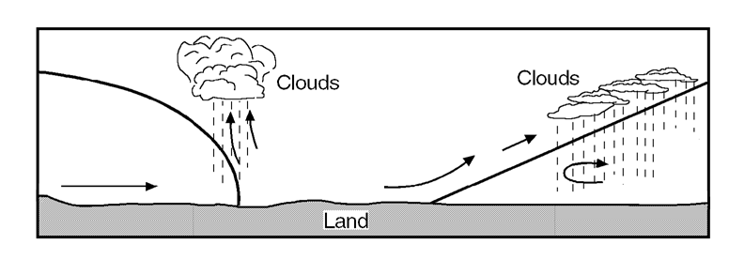

**E**

**D**

**C**

**B**

**A**

|  |  |  |
| --- | --- | --- |
| **LABEL** | **CIRCLE ONE** | DRAW FRONT SYMBOL OR CIRCLE ONE |
| Front A | Cold Front / Warm Front |  |
| Front B | Cold Front / Warm Front |  |
| Air Mass C | Cold / Cool / Warm | DENSITY: High / Medium / Low |
| Air Mass D | Cold / Cool / Warm | DENSITY: High / Medium / Low |
| Air Mass E | Cold / Cool / Warm | DENSITY: High / Medium / Low |

3. As a cold front catches up with a warm front, an occluded front forms. What happens to the warm air between the two frontal interfaces? (Circle one.)

A) The warm air is forced under the cold frontal interface but over the warm frontal interface.

B) The warm air is forced over both frontal interfaces.

C) The warm air is forced under both frontal interfaces.

D) The warm air is forced under the cold frontal interface but under the warm frontal interface.

4. Draw the map symbol for an occluded front.

5. Look at the weather map loop. Which is faster? **a cold front / a warm front**

6. In what general direction do cold fronts move across America? Warm fronts?

7. How should the weather **change** (before, during, after) as a cold front passes by? A warm front?

Before During After

Cold front

Warm front

8. Go to: <http://www.hpc.ncep.noaa.gov/html/sfcloop/namne_wbg.html>

Find this station in New York on the Northeast weather maps, and complete the table below

(For help on interpreting station models, go to:

<http://www.hpc.ncep.noaa.gov/html/stationplot.shtml>)

|  |  |  |  |  |  |  |  |  |  |
| --- | --- | --- | --- | --- | --- | --- | --- | --- | --- |
|  | Time | Temp. (ºF) | | DewPt. (ºF) | Pressure (mb) | Wind Direction | Wind Speed (kts) | | Sky Cover  (% cloudy) |
|  | 0000Z |  |  | |  |  | |  |  |
|  | **0300Z** |  |  | |  |  | |  |  |
|  | **0600Z** |  |  | |  |  | |  |  |
|  | **0900Z** |  |  | |  |  | |  |  |
|  | **1200Z** |  |  | |  |  | |  |  |
|  | **1500Z** |  |  | |  |  | |  |  |
|  | **1800Z** |  |  | |  |  | |  |  |
|  | **2100Z** |  |  | |  |  | |  |  |

12. A **meteogram** is a graphical depiction of trends in meteorological variables such as temperature, dew point, wind speed and direction, pressure, etc. The time series meteogram can be constructed using observed data or forecast data.

Using the data from the table above, complete the meteogram on the next page.

* For Temperature, Dew Point, Pressure and Wind Speed, make line graphs.
* For Wind Direction, draw a station model in the box showing where the wind is coming from. Examples:

::lolly.pct

* For Sky Cover, draw the proper map symbol in the box. Examples:

::cloud.pct

